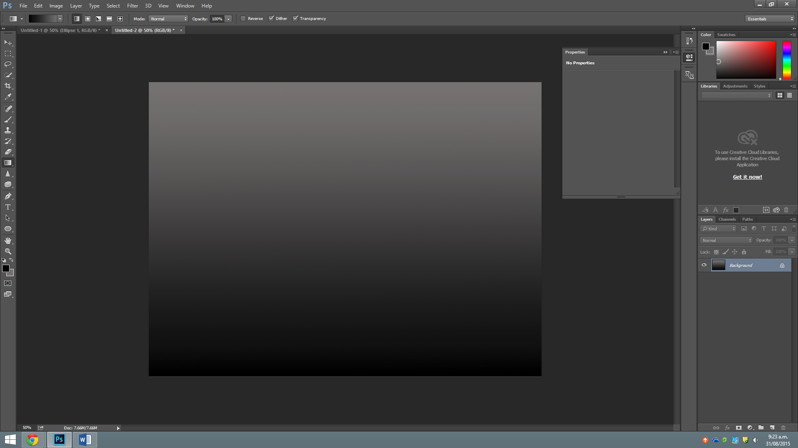

Started making the background picture.

**Evidence of advanced tools for images** (gradient fills, drop shadows, composition layer masks, converting colour modes, correcting image distortion and noise, pixel selections, drawing, and web graphics)

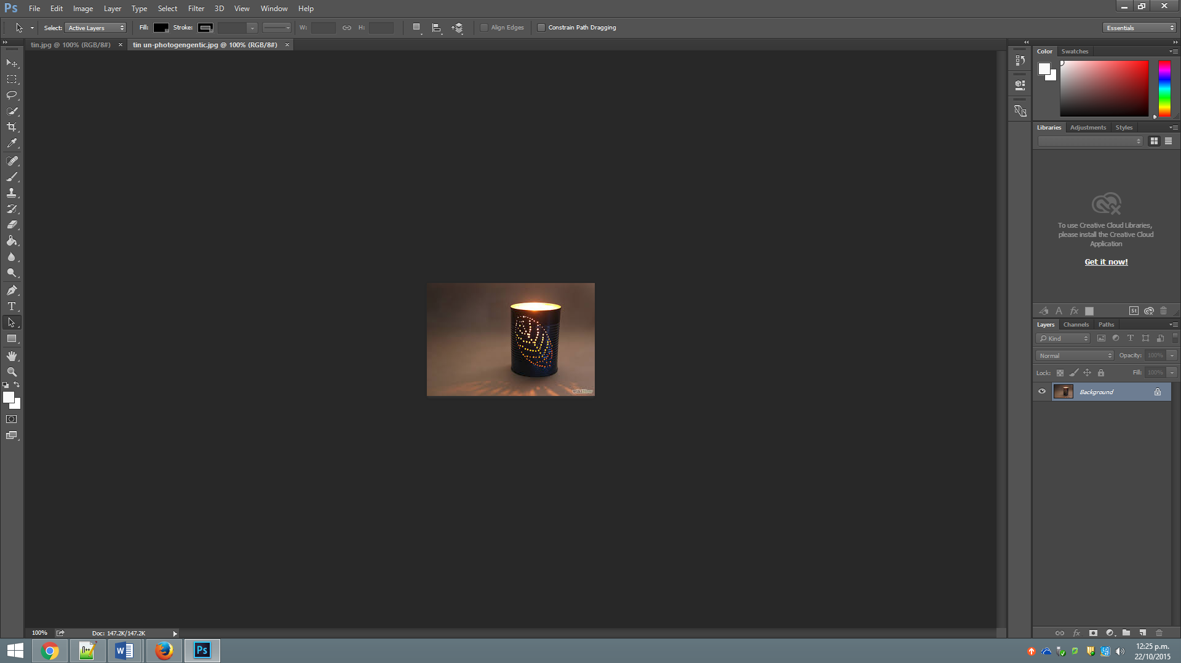

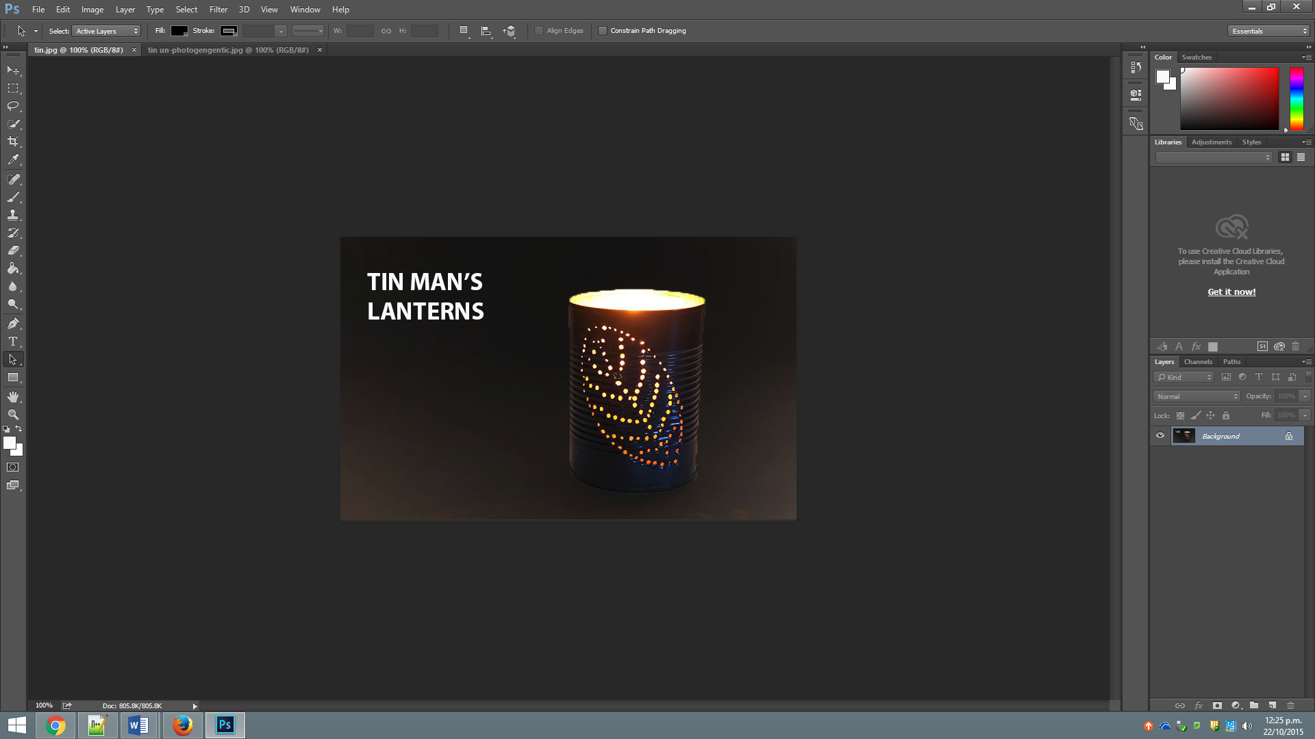

For these images above I have cropped the image. I have also added the name and then I have blacked out the background but I still have kept it light towards the bottom. This is the gradient affect.

**Stakeholder feedback**

I really enjoy this website a lot. Thank you! I’m glad we went over the planning stages and we went with those colour’s and that layout. I’m also really glad that you didn’t have the white spaces on the side but instead you’ve you used boxes and you have used a background instead.

**Testing in different browsers**   
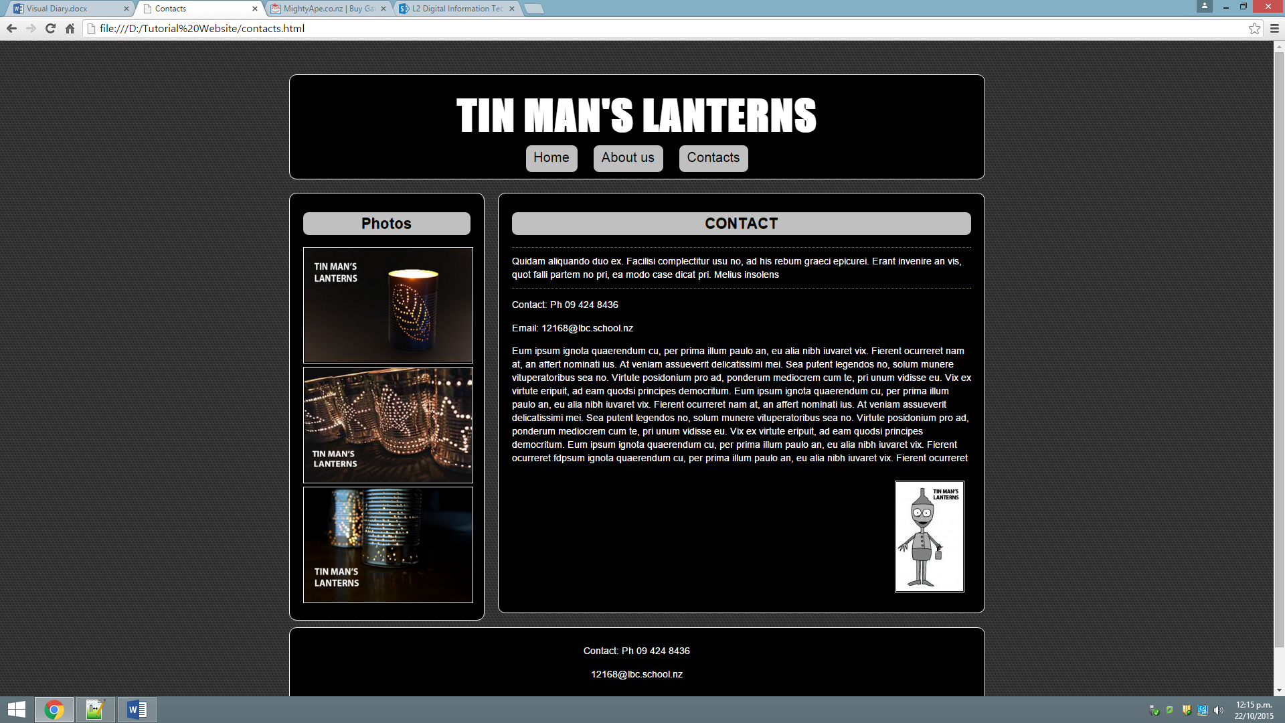

Google chrome testing

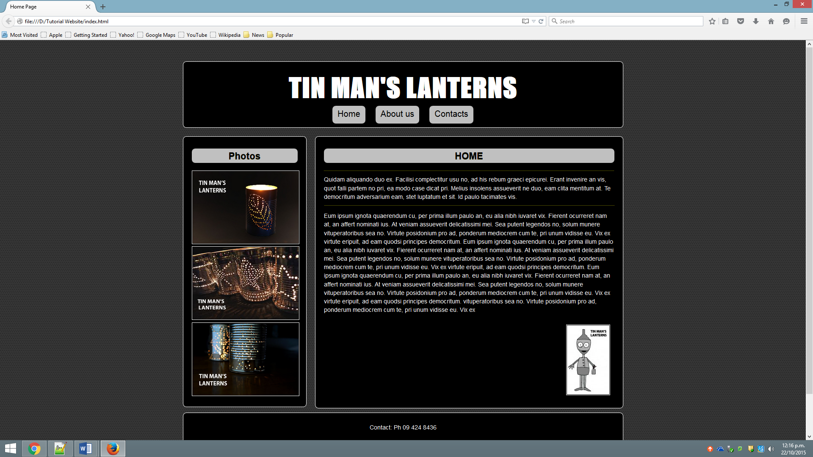

Firefox testing